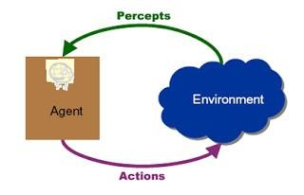

### Unit 2: Agents and Environment LH 7

Contents

Unit 2: Agents and Environment LH 7 1

• Contents: 2

Agent, Rational agent, intelligent agent 3

Basic terminology 5

Agents and Environments 7

Contd.. 10

Contd.. 10

Contd… 15

Omniscience Versus rationality 16

Environments 17

Properties of environment (classes of environment) 20

The structure of the agents 28

Contd… 40

Applications of the agents 40

Homework 42

### Contents:

**Contd…**

* + 2.1 Agent, Rational agent, and Intelligent Agent
  + 2.2 Relationship between agents and environments
  + 2.3 Environments and its properties(Fully observable vs. partially observable, single agent vs. multi-agent, deterministic vs. stochastic, episodic vs. sequential, static vs. dynamic, discrete vs. continuous, known vs. unknown)
  + 2.4 Agent structures
    - 2.4.1 Simple reflex agents
    - 2.4.2 Model-based reflex agents
    - 2.4.3 Goal-based agents
    - 2.4.4 Utility-based agents
    - 2.4.5 Learning agents
  + 2.5 Performance evaluation of agents: PEAS description

# Agent, Rational agent, intelligent agent

#### Agent:

* + An agent is just something that acts.

#### Rational Agent:

* + A Rational Agent is one that acts so as to achieve the best outcome or, when there is uncertainty, the best expected outcome.
    - I.e., one that behaves as well as possible.
  + How well an agent can behave depends on the nature of the environment; some environments are more difficult than others.

#### Intelligent agent:

**Contd…**

* + A Successful system can be called intelligent agent.
  + Fundamental faculties of intelligence are: Acting, Sensing, Understanding

,Reasoning, Learning

* + In order to act intelligent agent must sense. Blind actions is not characterization of intelligence. Understanding is essential to interpret the sensory percepts and decide on an action.
  + Therefore, Intelligent agent: Must act, Must sense, Must be autonomous, Must be rational.
  + **Note:** intelligent agent means it does things based on reasoning, while rational agent means it does the best action (or reaction) for a given situation.
  + However, Throughout this course we will use the term agent, rational agent and intelligence agent synonymously.

# Basic terminology

* **Percept:** Refer to the agent's perceptual inputs at any given instant.
* percept sequence:
  + An agent's percept sequence is the complete history of everything the agent has

ever perceived.

* + In general, an agent's choice of action at any given instant can depend on the entire

percept sequence observed to date.

* Agent Function:
  + The agent function is mathematical concept that maps percept sequence to actions(agent‟s behavior).

f : P* A

* **Agent Program:** The agent program is a concrete implementation of agent function

,running within some physical architecture to produce f.

**What do you mean, sensors, percepts effectors and actions?**

* **For Humans**
  + Sensors:
    - Eyes (vision), ears (hearing), skin (touch), tongue (gestation), nose

(olfaction).

* + Percepts:
    - At the lowest level – electrical signals from these sensors
    - After preprocessing – objects in the visual field, auditory streams .
  + Effectors:
    - limbs, digits, eyes, tongue, …..
  + Actions:
    - lift a finger, turn left, walk, run, carry an object, …

# Agents and Environments

* An agent is just something that acts.
* To act an agent perceives its environment via sensors and acts rationally upon that environment with its effectors (actuators).
* This simple idea is illustrated in the following figure:

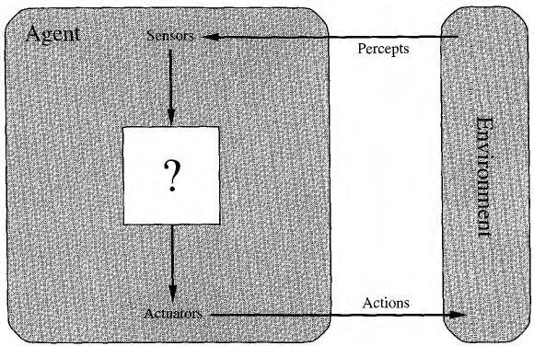

Fig: Agents interact with environments through sensors and actuators

#### Examples of Agent:

##### A human agent

* + - has eyes, ears, and other organs for sensors and hands, legs, mouth, and other body parts for actuators.

##### A robotic agent:

* + - might have cameras and infrared range finders for sensors and various motors for actuators.

##### A software agent:

* + - receives keystrokes, file contents, and network packets as sensory inputs and acts on the environment by displaying on the screen, writing files, and sending network packets.

#### Properties of the agent:

* + An agent is just something that act. Of course, all computer programs do something, but computer agent are expected to do more:
    - Operate autonomously i.e., can work on their own.
    - Perceive and react to their environment.
    - Pro- active (i.e., should be goal oriented)
    - capable of taking on another’s goal.
    - They are persistent over a prolonged time period. And
    - Adapt to change i.e., They should have ability to learn.

# Contd..

#### The vacuum-cleaner world: Example of Agent

* 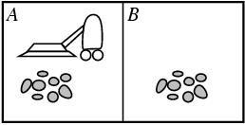To illustrate the intelligent agent, a very simple example-the vacuum-cleaner world is used as shown in Figure below:
* This world is so simple that we can describe everything that happens; it's also a made-up world, so we can invent many variations.
* This particular world has just two locations: squares A and B.
  + I.e. **Environment: square A and B**
* The vacuum agent perceives which square it is in and whether there is dirt in the

square.

* + **i.e., Percepts: [location and content] *E.g. [A, Dirty]***
* It can choose to move left, move right, suck up the dirt, or do nothing.
  + **i.e., Actions: left, right, suck, and no-op**

# Contd..

#### The vacuum-cleaner world: Example of Agent

###### One very simple agent function is the following:

* + if the current square is dirty, then suck, otherwise move to the other square.

###### A partial tabulation of agent function is shown in Table below:

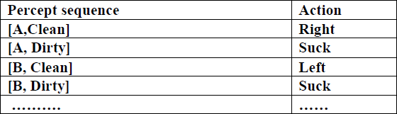

* A simple agent program for this agent function is given in the next slide.

**Contd..**

**The vacuum-cleaner world: Example of Agent**

* Function Vacuum Agent[location, Status] returns an action
  + If status = Dirty then Return suck
  + Else if location = A then Return Right
  + Else if location = B then return Left

**Good Behavior: The concept of rationality**

###### A rational agent is one that does the right thing i.e., one that behaves as well as possible.

* Right thing is the one that will cause the agent to be most successful.
  + For example: When an agent is in an environment, it generates a sequence of actions according to the percepts it receives. This sequence of actions causes the environment to go through a sequence of states. If the sequence is desirable, then the agent has performed well.

###### This notion of desirability is captured by a performance evaluation.

**Contd..** Performance Measures

* Evaluates any given sequence of environment states and determine the success of

the agent.

* But, It is not easy task to choose the performance measure of an agent. Because the performance measure doesn‟t depends on the task and agent but it depends on the circumstances.
* Therefore, It is better to design Performance measure according to what is wanted in the environment instead of how the agents should behave.
  + E.g., The possible performance measure of a vacuum-cleaner agent could be amount of dirt cleaned up, amount of time taken, amount of electricity consumed, amount of noise generated, etc.
  + But if the performance measure for automated vacuum cleaner is ―The amount of dirt cleaned within a certain time. Then a rational agent can maximize this performance by cleaning up the dirt , then dumping it all on the floor, then cleaning it up again , and so on.
  + So, “How clean the floor is” is better choice for performance measure of vacuum cleaner.

# Contd…

#### What is Rationality at any given time depends on four things:

* + The performance measure that defines the criterion of success.
  + The agent‟s prior knowledge of the environment
  + The actions that the agent can perform
  + The agent‟s percept sequence to date.

# Omniscience Versus rationality

###### An omniscient agent knows the actual outcome of its actions and can act

accordingly; but omniscience is impossible in reality.

* Rationality is not the same as perfection. Rationality maximizes expected performance, while perfection maximizes actual performance.

– For Example: I am walking along the Ring road one day and I see an old friend across the road. There is no traffic nearby and I'm not otherwise engaged, so, being rational, I start to cross the road. Meanwhile, at 33,000 feet, a cargo door falls off a passing airliner, and before I make it to the

other side of the road I am flattened.

# Environments

* + The first step to design a rational agent is the specification of its task

environment.

* + Task environments are essentially the „problems‟ to which rational agents are the „solutions‟.
  + Generally task environments are specified by using the following four

parameter

* + - Performance
    - Environment
    - Actuators
    - Sensors
  + Therefore, task environment is also called PEAS description of the environment.
* Example :PEAS description of the task environment for an Fully automated taxi
* **Performance:** The following can be the possible measures for the performance of

automated taxi:

* + Getting to the correct destination(destination).
  + Minimizing the fuel consumption and wear and tear (damage that naturally occurs as a result of aging), and minimizing the trip time or cost (Profit)
  + Minimizing the violations of traffic laws and disturbances to other drivers(legality)
  + Maximizing the safety and passenger comfort (Safety and comfort)
* **Environment:** This is the driving environment that the taxi will face
  + Streets/freeways, other traffic, pedestrians, weather (rain, snow, etc.), police cars, etc.
  + **Actuators:** The Actuators for an automated taxi include those available to a human driver:
    - Steering, accelerator, brake, horn, speaker/display,…
  + **Sensors:** The basic sensors for the taxi includes :
    - One or more controllable video cameras to see the road
    - Infrared and sonar sensors to detect the distances to other cars and obstacles
    - To avoid speeding tickets, the taxi should have a speedometers
    - To control the vehicle on the curve it should have an accelerometer
    - To determine the mechanical state of the vehicle , it should have engine sensors.
    - It should have GPS so that it doesn‟t get lost.
    - It should have keyboard or microphone for the passenger to request the destination.

## Properties of environment (classes of environment)

* Following are the dimensions along which environment can be categorized:
  + Fully observable versus partially observable
  + Single agent versus multi-agent
  + Deterministic versus stochastic
  + Episodic versus sequential
  + Static versus dynamic
  + Discrete versus continuous
  + Known versus unknown.

#### Fully observable versus partially observable:

* + If an agent's sensors give it access to the complete state of the environment at each point in time, then we say that the task environment is fully observable.
    - For example: chess playing.
  + An environment might be partially observable because of noisy and inaccurate sensors.
    - For example:

– a vacuum agent with only a local dirt sensor cannot tell whether there is dirt in other squares.

#### Single agent vs. multi-agent:

* **Example:** an agent solving a crossword puzzle by itself is clearly in a single-agent environment, whereas an agent playing chess is in a two-agent environment.
* Multi-agent environment can be:
  + **Competitive**: For example, in chess, the opponent entity B is trying to maximize its performance measure, which, by the rules of chess, minimizes agent A's performance measure. Thus, chess is a competitive multi-agent environment.
  + **Cooperative**: In the taxi-driving environment, on the other hand, avoiding collisions maximizes the performance measure of all agents, so it is a partially cooperative multi-agent environment.

#### Deterministic vs. stochastic:

* + If the next state of the environment is completely determined by the current state and the action executed by the agent, then we say the environment is deterministic; otherwise, it is stochastic.
  + The simple vacuum world is deterministic where as the Taxi driving is clearly stochastic in this sense, because one can never predict the behavior of traffic exactly; moreover, one's tires blow out and one's engine seizes up without warning.

#### Episodic versus sequential:

* + In episodic environments, the choice of action in each episode depends only on the episode itself i.e., the next episode does not depend on the actions taken in previous episodes.
    - For example an agent that has to spot defective parts on an assembly line bases each decision on the current part, regardless of previous decisions; moreover, the current decision doesn't affect whether the next part is defective.
  + In sequential environments, on the other hand, the current decision

could affect all future decisions.

* + - For example: Chess and taxi driving are sequential

#### Static vs. dynamic:

* + If the environment can change while an agent is deliberating, then the

environment is dynamic for that agent; otherwise, it is static.

* + Static environments are easy to deal with because the agent need not keep looking at the world while it is deciding on an action, nor need it worry about the passage of time.
    - For Example: Crossword puzzles are static.
  + Dynamic environments, on the other hand, are continuously asking the agent what it wants to do; if it hasn't decided yet, that counts as deciding to do nothing.
    - For example: Taxi driving is dynamic because the other cars and the taxi

itself keep moving while the driving algorithm differs about what to do next.

#### Discrete vs. continuous:

* + The discrete/continuous distinction can be applied to the state of the environment, to the way time is handled, and to the percepts and actions of the agent.
    - For example, a discrete-state environment such as a chess game has a finite number of distinct states. Chess also has a discrete set of percepts and actions.
    - Example of continuous state environment includes Taxi driving : the speed and location of the taxi sweep through a range of continuous values and do so smoothly over time.

#### Known versus unknown:

* + This distinction refers not to the environment itself but to the agent‟s

state of knowledge about the environment.

* + In a known environment, the outcomes for all actions are given.
  + Obviously, if the environment is unknown, the agent will have to learn how it works in order to make good decisions.

# The structure of the agents

#### Agent‟s structure can be viewed as:

* Agent = Architecture + Agent Program
  + Architecture = the machinery that an agent executes on.
  + Agent Program = an implementation of an agent function.

#### Agents are grouped into five classes based on their degree of perceived intelligence and capability:

* + - simple reflex agents
    - model-based reflex agents
    - goal-based agents
    - utility-based agents
    - learning agents

#### Simple reflex agents:

* + - Simple reflex agents act only on the basis of the current percept, ignoring the rest of the percept history.
      * For example: vacuum cleaner agent.
    - First of all the simple reflex agent perceives the percepts from the environment and the agent interpret input to generate an abstract state description of the current state from the percept.
    - This generated state description is then matched against the condition part of the rules in the rule set.
    - Then it act according to a first rule whose condition matches the current

state , as defined by the percept.

* The following figure shows the structure of the simple reflex agent

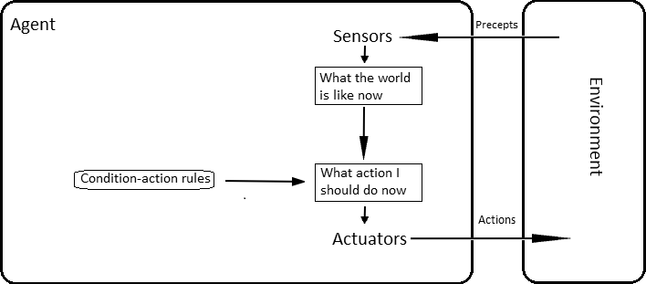

Fig: simple reflex agent

#### Characteristics:

* + - simple, but very limited intelligence.
    - The simple reflex agent work only if the environment is fully observable. Even a little bit of unobservability can cause serious trouble.
    - Lacking history, easily get stuck in infinite loops

#### Model Based Reflex agent:

* Maintain a internal state to keep track of part of world it can not see

now.

* Internal state is based on percept history and keeps two kinds of knowledge:
  + how the world evolves independently of the agent
  + How the agent's own actions affect the world
* Then it combines current percept with the old internal state to generate

the updated description of the current state.

* It then chooses an action in the same way as reflex agent.
  + The following figure shows the structure of the model based reflex agent

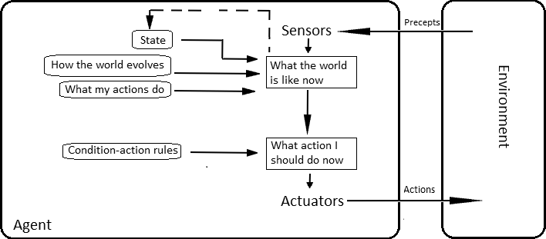

Fig: Model based reflex agent

#### Goal Based agent:

* + - Goal-based agents further expand on the capabilities of the model-

based agents, by using "goal" information.

* + - Goal information describes situations that are desirable. This allows the agent a way to choose among multiple possibilities, selecting the one which reaches a goal state.
    - It is more flexible because the knowledge that supports its decisions is

represented explicitly and can be modified.

* + The following figure shows the structure of the goal based agent

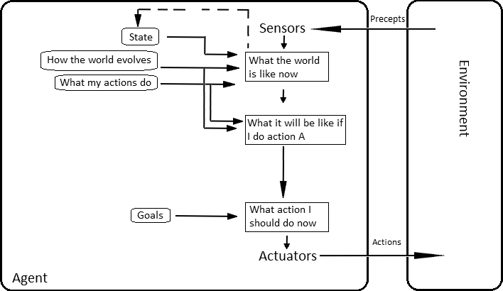

Fig: Goal base agent

#### Utility based agent:

* + - Goal-based agents only distinguish between goal states and non-goal

states.

* + - It is possible to define a measure of how desirable a particular state is. This measure can be obtained through the use of a *utility function* which maps a state to a measure of the utility of the state.
    - A more general performance (for example, speed and safety)measure should allow a comparison of different world states according to exactly how happy they would make the agent. The term utility can be used to describe how "happy" the agent is.
  + The following figure shows the structure of the utility based agent

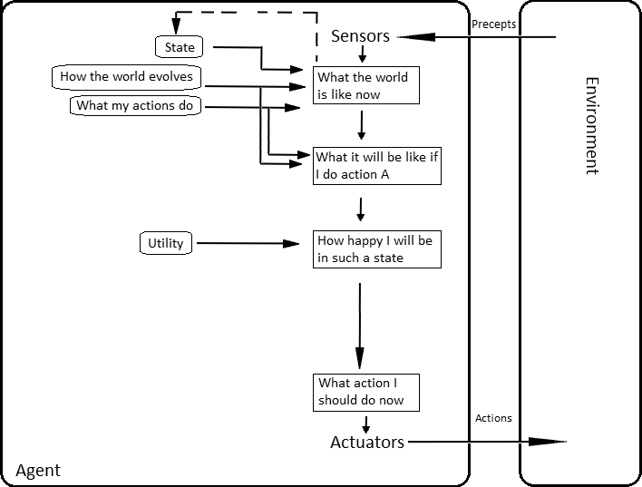

Fig: utility base agent

**Contd…**

#### Learning agents: A learning agent can be divided into four

conceptual components:

* + **"learning element**", which is responsible for making improvements
  + **"performance element“ (**entire agent**)**, which is responsible for selecting external actions. i.e., it takes in percepts and decides on actions.
  + The learning element uses feedback from the "**critic**" on how the agent is doing and determines how the performance element should be modified to do better in the future.
  + The last component of the learning agent is the "**problem generator**". It is responsible for suggesting actions that will lead to new and informative experiences.

# Contd…

* following figure shows the structure of the Learning agent

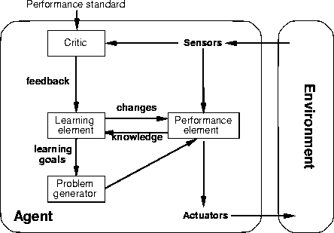

Fig: Learning base agent

# Applications of the agents

* Intelligent agents are applied as automated online assistants, where they function to perceive the needs of customers in order to perform individualized customer service.
* Such an agent may basically consist of a dialog system, as well an expert system to provide specific expertise to the user.
* They can also be used to optimize coordination of human groups online.

# Homework

* Define in your own words the following terms: agent, agent function, agent program, rationality, autonomy, reflex agent, model-based agent, goal- based agent, utility-based agent, learning agent.
* Both the performance measure and the utility function measure how well

an agent is doing. Explain the difference between the two

* What is the differences between agent functions and agent programs.
* What an agent comprises of?
* What are the various task environments?

**Thank You !**

